Show all work that leads to your answers! No work, no credit.
This is the work for the entire week. The breakdown should be as follows:
Tuesday #24-28
Wednesday #4 free response
Thursday #24-29 (different problems than Tuesday)

***VERY IMPORTANT: ALL work is due by midnight on Friday, June 5.***

TUESDAY
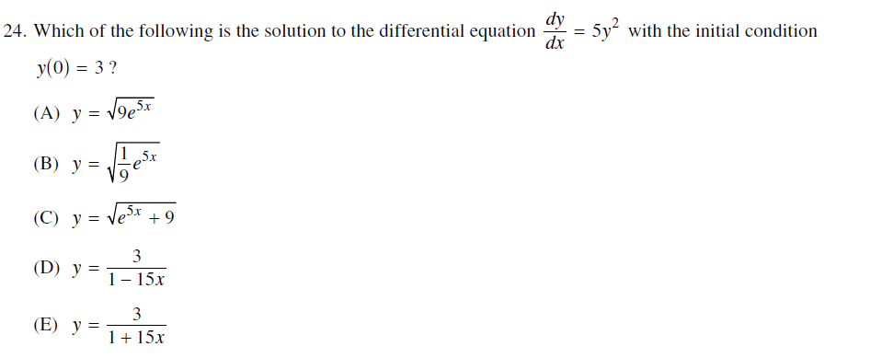
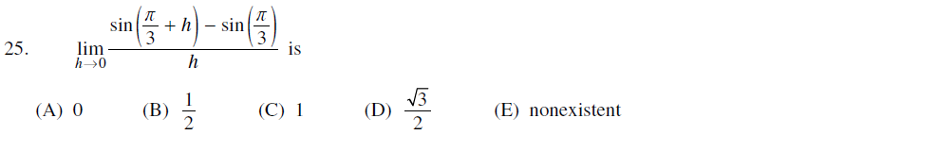
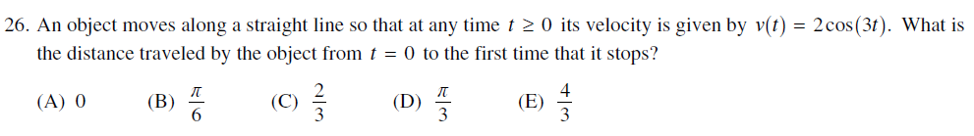
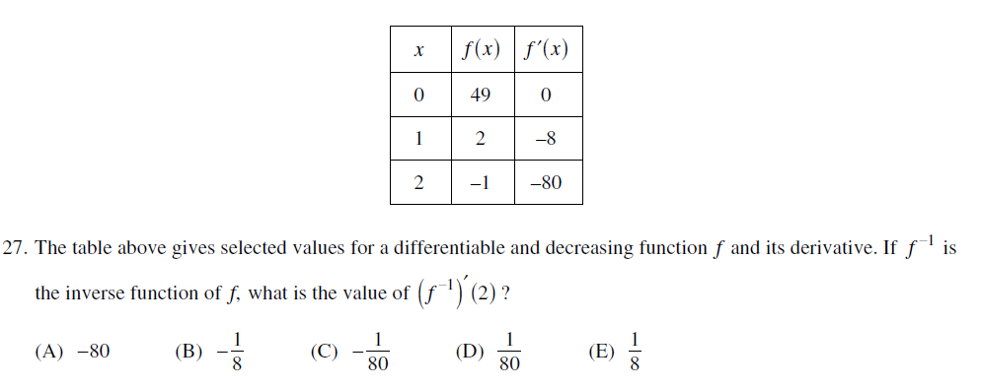
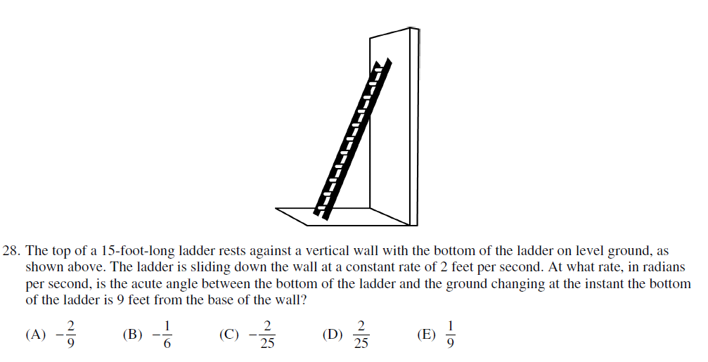

WEDNESDAY
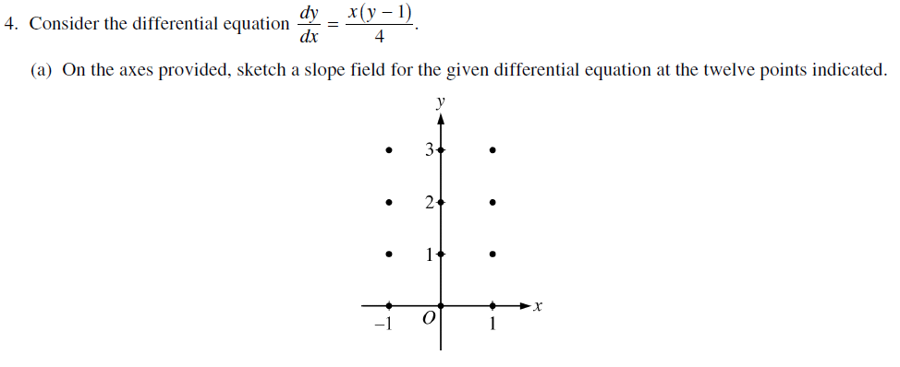
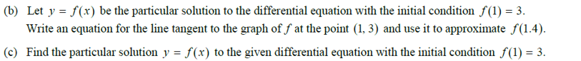

THURSDAY
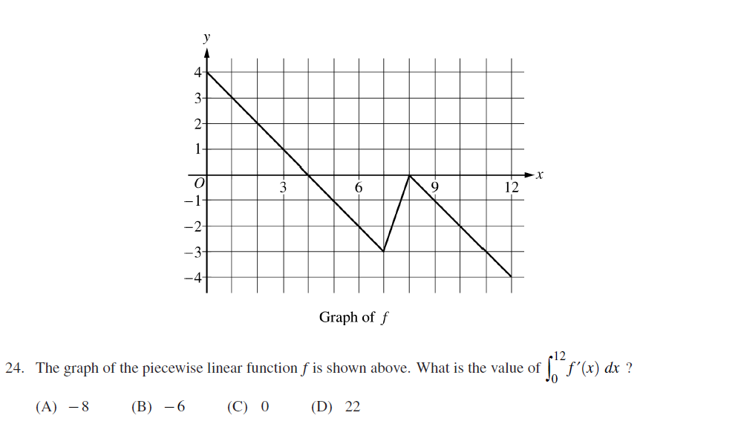
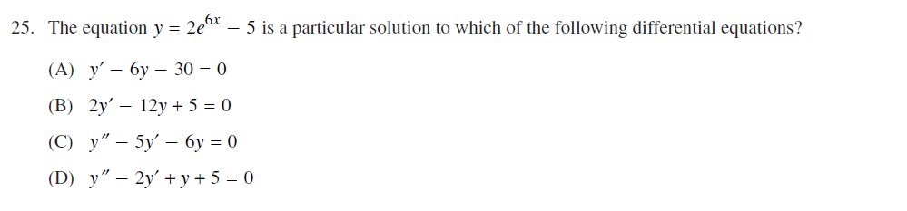
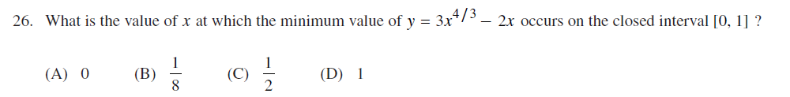
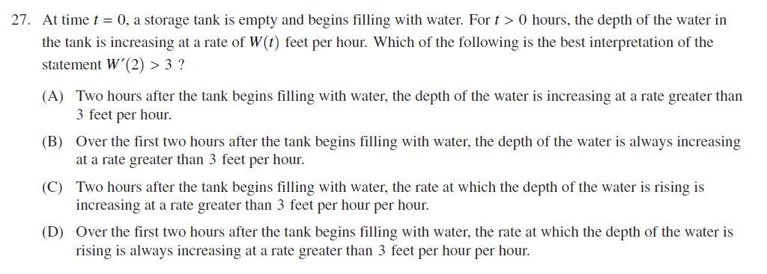
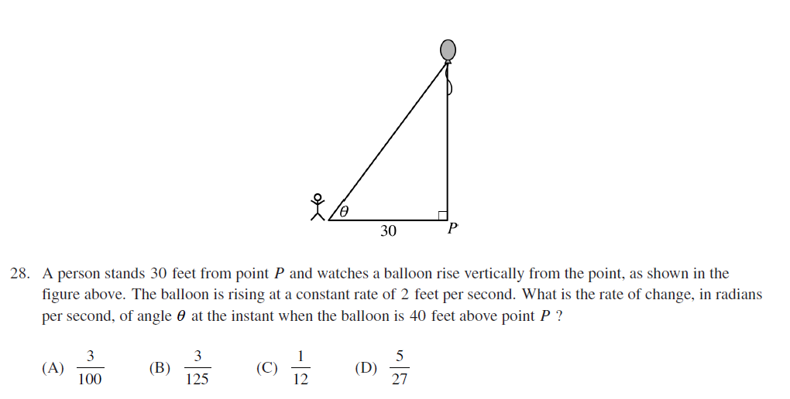
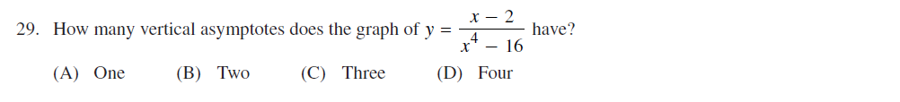

TUESDAY’S ANSWERS

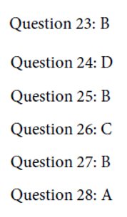

WEDNESDAY’S ANSWERS

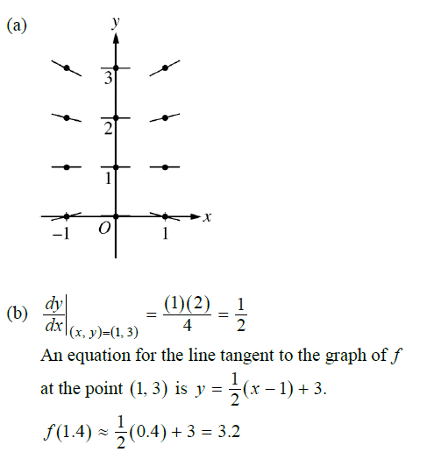
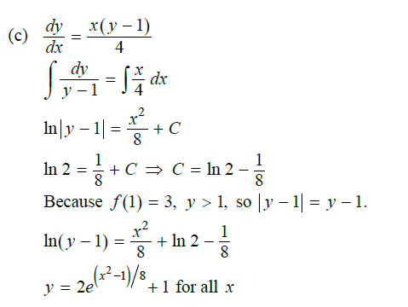
THURSDAY’S ANSWERS
