**Lesson 1.1**

a. integer, rational, real

b. natural, whole, integer, rational, real

c. irrational, real

d. rational, real

**Lesson 1.7**

a. x = -11, -7

b. no solutions

c. x = -6, 4

d. x = -9, -1

**Lesson 5.1**

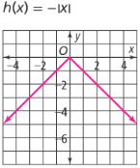a. 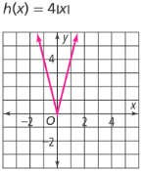 b. 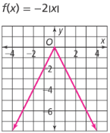 c.

|  |  |  |
| --- | --- | --- |
| Domain:  Range: | Domain:  Range: | Domain:  Range: |

**Lesson 5.2**

a.  b. 

c. 

**Lesson 5.4**

a. vertex at (-8, 0); axis of symmetry at x=0; left 8, vertically compressed by a factor of ½

b. vertex at (5, -9); axis of symmetry at x=5; right 5, down 9

c. vertex at (0, 3); axis of symmetry at x=0; up 3, vertically reflected over the x-axis, vertically stretched by a factor of 2

d. 

e. 