­­**Lesson 6.1 – exponent properties**

|  |  |  |
| --- | --- | --- |
| a. | b. | c. |
| d. | e. | f. |

**Lesson 6.2 – exponential functions**

Write an exponential function given the information provided for each question.

|  |  |
| --- | --- |
| a. starting value = 7, constant multiplier = 2 | Equation: ____________________ |
| b. starting value = 1, constant multiplier = | Equation: ____________________ |
| c.   |  |  |  |  |  | | --- | --- | --- | --- | --- | | x | 0 | 1 | 2 | 3 | | y | 64 | 16 | 4 | 1 | | Equation: ____________________ |
| d.   |  |  |  |  |  | | --- | --- | --- | --- | --- | | x | 0 | 1 | 2 | 3 | | y | 11 | 33 | 99 | 297 | | Equation: ____________________ |
| e. | Equation: ____________________ |

**Lesson 6.3 – exponential growth and decay**

Write the growth/decay factor under the following growth/decay rates.

|  |  |  |
| --- | --- | --- |
| a. 72% growth | b. 12% decay | c. 3.5% decay |
|  |  |  |
| d. 22.2% growth | e. 91.6% decay | f. 104% growth |
|  |  |  |

g. Determine the value of an account that started with $14,000 with annual interest of 4% compounded bi-annually, after 11 years.

Compound interest:  Value after 11 years: __________

**Lesson 6.5 – transformation of exponential functions**

Identify all of the transformations in each of the following functions.

|  |  |
| --- | --- |
| Functions | Transformations |
| a. |  |
| b. |  |
| c. |  |
| d. |  |

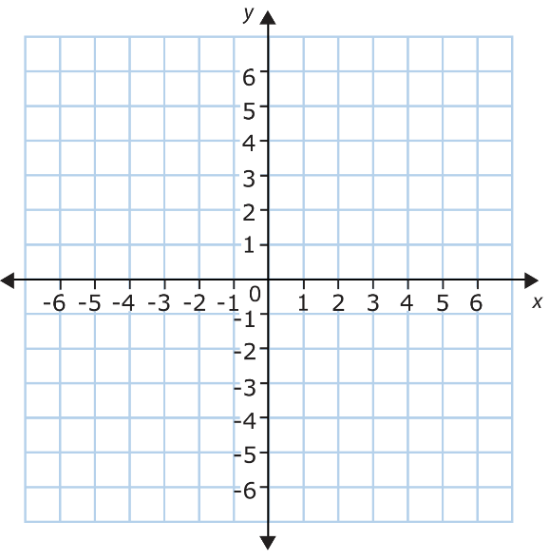Graph each function on the grid to the right.

e. 

f. 