**Topic 9 Tuesday Review**

1. Use the graph to find 2. Use the graph to find

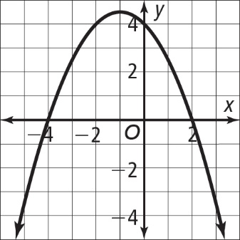 the solutions of  the solutions of  .

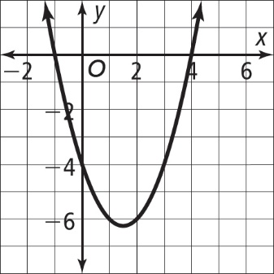

3. Find the solutions of the equations by factoring:

a.  b.  c. 

4. Write the factored form for the quadratic function.

 a. b.

5. Solve each equation.

a.  b.  c. 