Topic 9 Wednesday Review
1. Given the function write the axis of symmetry and the vertex.
A $f\left(x\right)=x^{2}-30x+71$ B $f\left(x\right)=x^{2}+24x-4$
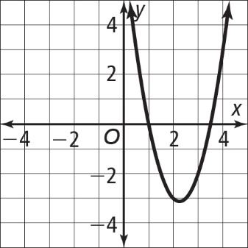
2. Which of the statement(s) about the graph shown
are true? Select all that apply.

A An equation for the graph is $y = 2x^{2} - 9x + 7$.
B The function has two roots.
C The solutions of the related quadratic equation are
$-1.5$ and $-3.$
D The related quadratic equation has two solutions.

3. Find the discriminant for the following quadratic equations. State how many solutions the equation has.
a. $x^{2} + 7x – 2=0$ b. $8x^{2}-10x+15=0$
c. $-2x^{2}– 9x + 3=0$ d. $x^{2}+2x + 1=0$

4. Use the quadratic formula to solve the following equations
a. $4x^{2} + 13x + 5 = 0.$ b. $2x^{2} + 23x + 17 = 0$

